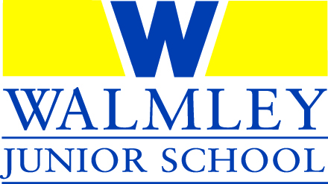

WALMLEY JUNIOR SCHOOL
GOVERNING BODY STRATEGIC STATEMENT

School Aims
Walmley Junior School works hard to ensure that the children who attend the school are not only educated but are nurtured and cared for and are given the best start in life.
The school aims to provide a high quality of education and an environment where children have fun, develop a passion for learning and create lasting memories from the opportunities the creative curriculum has to offer.
Hugely proud of our consistent, high academic results, excellent standards of behaviour and level of care which enabled us to achieve ‘Outstanding’ in the Ofsted inspection in January 2014, the school is not complacent and is keen to ensure this success is built upon even further to ensure the children have the best possible experience and attainment and feel well prepared for the next stage of their education journey, enabling them to contribute in a positive manner to life in the local community.

Walmley Values
Our values of respect, honesty, kindness, generosity, perseverance, politeness and conscientiousness underpin everything that is done at the school and are truly embedded within the whole school environment.

School Objectives
The objectives of the school are articulated in the School Improvement Plan which is updated annually and monitored throughout the year in conjunction with the Governing Body.

WJS Governing Body
Purpose
The Governing Body exists to make sure that the school runs effectively. Governors do not involve themselves in the day to day running of the school but work strategically to undertake the core functions of the Governing Body:
- ensuring clarity of vision, ethos and strategic direction;
- holding the executive leaders to account for the educational performance of the organisation and its pupils, and the performance management of staff;
- overseeing the financial performance of the organisation and making sure its money is well spent
- setting and monitoring the Strategic Development and performance of the school.

Objectives
In undertaking those core functions, the objectives of the Governing Body are:
- To ensure the school provides excellent teaching and learning opportunities by attracting and retaining well qualified and motivated staff
- To ensure effective financial management of the school and the use of income and funding to its best possible effect to ensure access to high quality resources for all who need them.
- To continue to give children the opportunity to develop themselves beyond the formal curriculum.
- To ensure that the school continues to provide a safe and welcoming environment for pupils, staff and visitors alike.
- To ensure effective governance of the school.
- To contribute to the maintenance of the current Ofsted Outstanding rating.
- To continue to provide any additional support required by the Headteacher and staff following the pandemic and other ongoing challenges of the external environment.
- To ensure that the health and wellbeing of the children and staff are always at the forefront of our minds and offer support where necessary.

Actions
The Governor Body will achieve these objectives by:
- Ensuring that the School Self Evaluation Form (SEF) which forms part of the School Improvement Plan, is updated regularly.
- Ensuring that the Schools Improvement Plan (SIP) is monitored regularly.
- Overseeing the school’s finances to ensure they are monitored and that the school remains within budget.
- Ensuring that data provided by the school, and relevant external organisations, is monitored and actioned as necessary.
- Ensuring the career development and training of teachers, teaching assistants and all members of School team is continual and relevant.
- Ensuring the school remains a safe environment for the staff and children.
- Completing a regular analysis of the individual skills of Governors and the effectiveness of the Governing Body itself
- Attending all relevant training to continue their effectiveness as Governors.

