After school hot snacks update!

After our initial trial, the hot snack choices have been a real success. From January 2023, all hot snack options will be priced at £1.20. Hot snacks can be ordered each night by your child or by you speaking to a member of Earlybirds staff. The charge will be added to your monthly Earlybirds Invoice.

Monday Tin on Toast (beans or spaghetti hoops)  Tomato Soup  Chicken Soup  Toast (butter and jam)  Special – Sausage Roll (vegan option available)  Special – Cheese and Tomato Pizza  Tuesday Tin on Toast (beans or spaghetti hoops)  Tomato Soup  Chicken Soup  Toast (butter and jam)  Special – Sausage Roll (vegan option available)  Special – Cheese and Tomato Pizza  Wednesday Tin on Toast (beans or spaghetti hoops)  Tomato Soup  Chicken Soup  Toast (butter and jam)  Special – Sausage Roll (vegan option available)  Special – Cheese and Tomato Pizza  Thursday Tin on Toast (beans or spaghetti hoops)  Tomato Soup  Chicken Soup  Toast (butter and jam)  Special – Sausage Roll (vegan option available)  Special – Cheese and Tomato Pizza  Friday Tin on Toast (beans or spaghetti hoops)  Tomato Soup  Chicken Soup  Toast (butter and jam) | 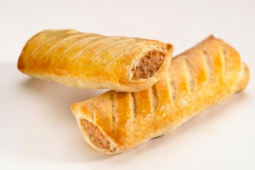
 | 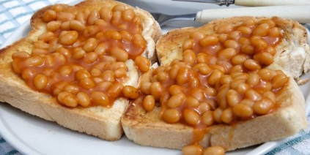
 | 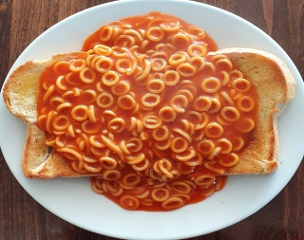
 | 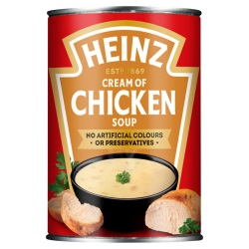 | 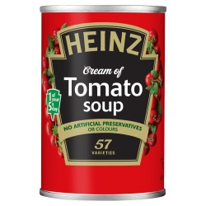
 | 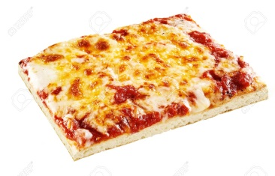
Special – Sausage Roll (vegan option available)
Special – Cheese and Tomato Pizza

