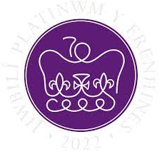
6th May 2022

A Banquet fit for a Queen

Dear Parent/Carers,

The kitchen will be doing a Queen’s 70th Jubilee lunch on Thursday 26th May 2022. We would like to give the children who normally have sandwiches the opportunity to have a lunch.

The menu for the day will be:
Sausage Roll
Vegan Sausage Roll (V)
*
Chicken Nuggets
Quorn Dippers (V)
*
A choice of Sandwiches (V)
*
Carrot & Cucumber Sticks
Crisps
*
Jubilee Biscuit
Fruit Platter

If you would like your child to have a lunch, the cost is £2.50. Payment for this can be made using Scopay on line payment system. Jubilee lunch can be found in ‘Products’ then ‘Jubliee lunch’. We are asking for payment to be made in advance please, as this will ensure your child receives a lunch on that day. Payment should be made no later than Monday 16th May 2022.

If your child normally has a lunch on Thursday’s they will automatically get this special lunch.

Yours sincerely,

Mrs S. Bean
Catering Manager

L:\2021-2022 Letters\Special Jubliee lunch May 22.docx

