After school hot snacks update!

All hot snacks will continue to be charged at £1 during the Summer Term as we are still assessing how popular these are after school. Hot snacks can be ordered each night by your child or by you speaking to a member of Earlybirds staff. The charge will be added to your monthly Earlybirds Invoice.

Monday Tin on Toast (beans or spaghetti hoops)  Tomato Soup  Chicken Soup  Toast (butter and jam)  Special – Sausage Roll (vegan option available)  Special – Cheese and Tomato Pizza  Tuesday Tin on Toast (beans or spaghetti hoops)  Tomato Soup  Chicken Soup  Toast (butter and jam)  Special – Sausage Roll (vegan option available)  Special – Cheese and Tomato Pizza  Wednesday Tin on Toast (beans or spaghetti hoops)  Tomato Soup  Chicken Soup  Toast (butter and jam)  Special – Sausage Roll (vegan option available)  Special – Cheese and Tomato Pizza  Thursday Tin on Toast (beans or spaghetti hoops)  Tomato Soup  Chicken Soup  Toast (butter and jam)  Special – Sausage Roll (vegan option available)  Special – Cheese and Tomato Pizza  Friday Tin on Toast (beans or spaghetti hoops)  Tomato Soup  Chicken Soup  Toast (butter and jam) | 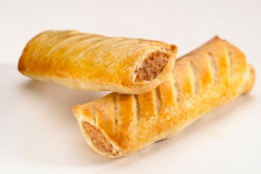
 | 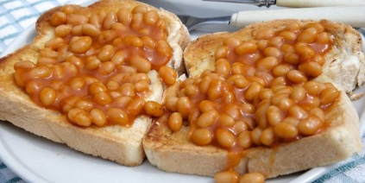
 | 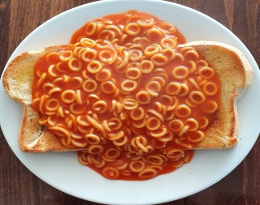
 | 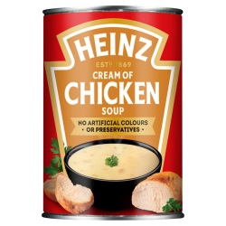 | 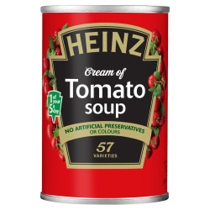
Special – Sausage Roll (vegan option available)
Special – Cheese and Tomato Pizza

