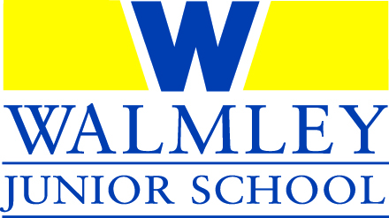
End of Key Stage 2 Assessment Results 2019
This year pupils were given a scaled score from 80 to 120. The expected standard was a scaled score of 100. Our school was moderated by the LA for writing this year.
The national combined standard for pupils who achieved the expected standard in reading, writing and mathematics was 65%. As a school we achieved 72%.
The national combined standard for pupils which achieved the higher standard in reading writing and mathematics was 11%. As a school 17% of pupils achieved this standard.
Key Stage 2 - % achieving the expected standard or above in: | School Expected Standard | National Expected Standard | School Higher Standard | National Higher Standard | Our School Average Scaled Score | National Average Scaled Score
Reading (test) | 77% | 73% | 33% | 27% | 105 | 104
Writing* | 90% | 78% | 29% | 20% | ----- | -----
Grammar, punctuation and spelling (test) | 88% | 78% | 59% | 36% | 110 | 106
Mathematics (test) | 92% | 79% | 43% | 27% | 108 | 105

*Teacher assessment based on a wide range of pieces from pupils’ books
Progress score in reading, writing and maths
Reading | Writing | Mathematics
0.7 (Average) | 2.6 (Well above average) | 3.2 (Well above average)

Performance Tables
For further information on our school results see our page on the Government's School and College Performance comparison website:
https://www.compare-school-performance.service.gov.uk/school/103543/walmley-junior-school

